## horizontal line



Housing Vacancy for NYC

08.11.2024

**─**

Elif Celebi,

Zaineb Konialian,

Carlos Ortiz,

Talibah Timothy

**Executive Summary**

# The Purpose

New York is an international cultural hub. “The City that Never Sleeps” as it is so fondly nicknamed offers dreamers the opportunity to pursue their dreams. “The City that Never Sleeps” has 3,644,000 housing units in 2021, according to the Rent Guidelines Board website.

# Goals

1. To analyze the vacancy trends in New York Counties and surrounding counties.
2. To analyze the job, mobility, and mortgage trends in New York Counties and surrounding counties.

# Proposal

* + How did the job market impact the house market in NYC and Surrounding Counties?
  + What is Vacancy Rate in NYC Boroughs before and after lockdown in 2020?
  + What is the Housing Value before and after lockdown in NYC and Surrounding Counties ?
  + What is the relationship between inflation and Housing Value in NYC and Surrounding Counties ?
  + How did mobility impact the house market in NYC and Surrounding Counties ?

# Problem Statement

Analyze trends in housing availability and affordability in NYC between 2013 and 2023. Take into consideration regional and overall trends in employment/income, population, mortgage interest rates, home value, and housing vacancy rates.

# Hypotheses

The 2020 pandemic lockdown decreased NYC housing values and increased NYC housing supply, particularly:

* Housing Value (as a metric of availability) went down
* Housing Vacancy Rate (as a measure of affordability) went up

Employment/Income and Population trends and changes further characterize changes to housing value and availability.

# Scope

* New York City five boroughs
* Surrounding counties to New York City’s five boroughs
* Time frame: 2012 - 2023

# Data Sourcing Specifications

**Census Data:**

* + Housing Vacancy Rate for NYC boroughs and overall (ACS 1Y DP04)
  + Geographical Mobility in the Past Year by Tenure for Current Residence in the US

**Bureau of Labor Statistics:**

* + Bureau of Labor Statistics: North American Industry Classification System (NAICS)
  + Area (County) Quarterly Reports on Wages Data as CSV

**Zillow:**

* + Zillow Housing Value Index (ZHVI)
  + Data download CSV

**Inflation Data:**

* + Mortgage rates download as CSV
  + Average Mortgage Rate per Year

**Methodology**

**Data Collection**

Data was pulled directly from the sources Census, Zillow, and Bureau of Labor Statistics and used as csv. Data from bankrate.com was published on the site, copied and pasted to csv to use the data between 2012 -2022.

# Data Preparation and Cleaning

New York is an international cultural hub. “The City that Never Sleeps” as it is so fondly nicknamed offers dreamers the opportunity to pursue their dreams. “The City that Never Sleeps” has 3,644,000 housing units in 2021, according to the Rent Guidelines Board website.

# Analysis Techniques

New York is an international cultural hub. “The City that Never Sleeps” as it is so fondly nicknamed offers dreamers the opportunity to pursue their dreams. “The City that Never Sleeps” has 3,644,000 housing units in 2021, according to the Rent Guidelines Board website.

**Data Analysis**

# Development/Findings:

**Job Distribution in NY Counties and Surrounding Counties:**

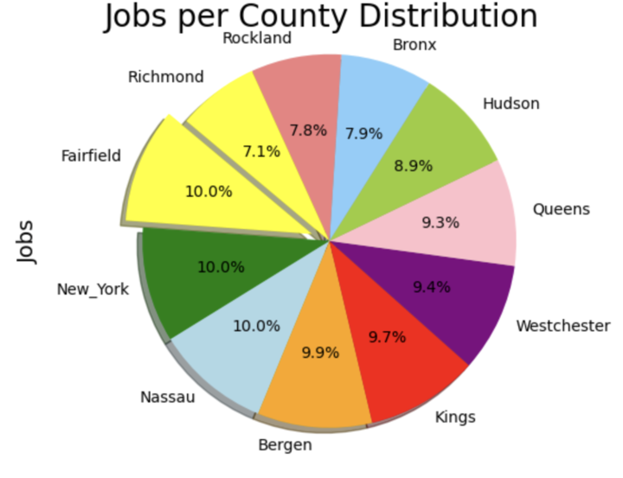

**Correlation Metrics for Year Wages and Month of Employment:**

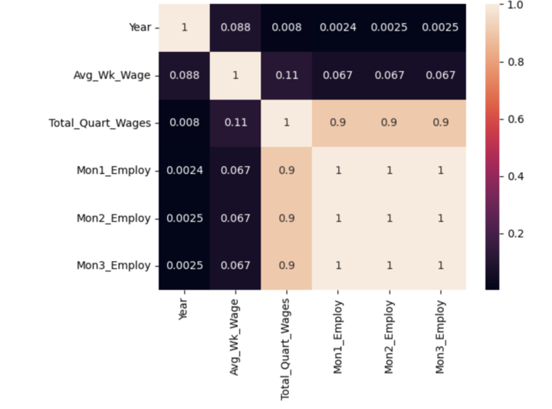

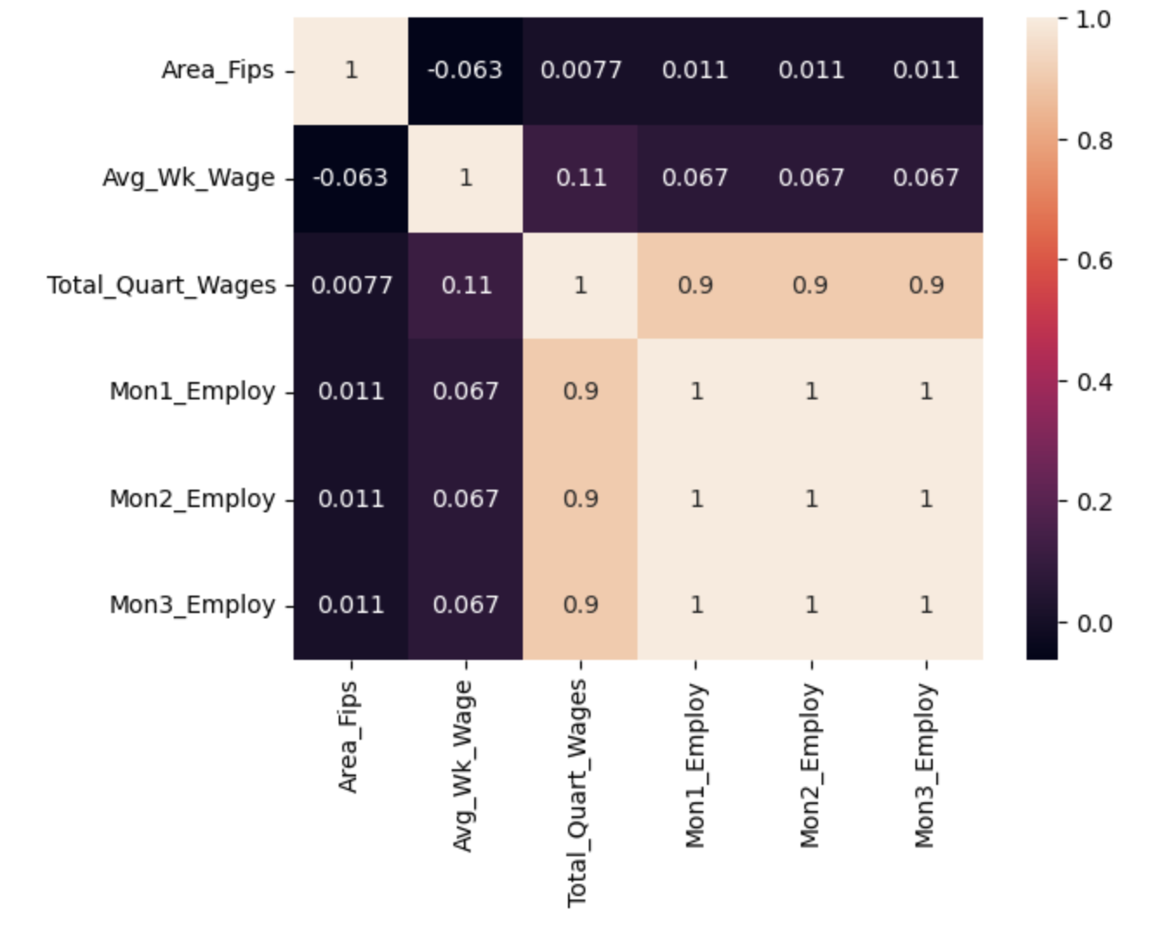

**Weekly Wages in NY and Surrounding Counties:**

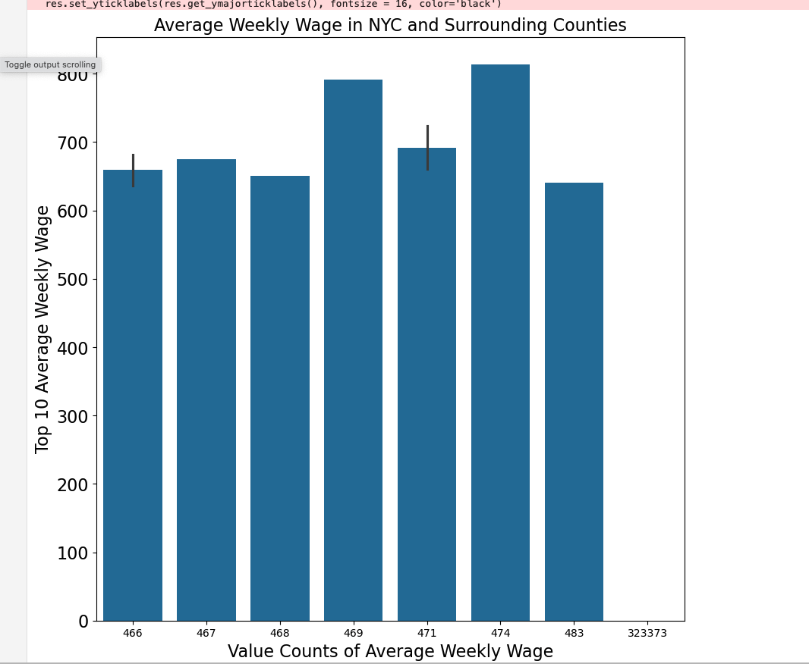

**Industry Categories in NY and Surrounding Counties:**

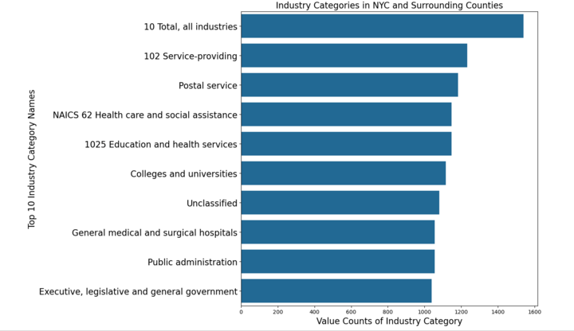

# Model Evaluation/Results with Labor:

* Based on the Analysis, Fairfield County (CT), New York County (NY), and Nassau County (NY)have the highest distribution of jobs from (2012-2022). Service providing and postal service are among the most popular industries of where people work.
* At the end of the year, the average weekly percentage did not change significantly to affect wages.

**Mobility Population in NYC:**

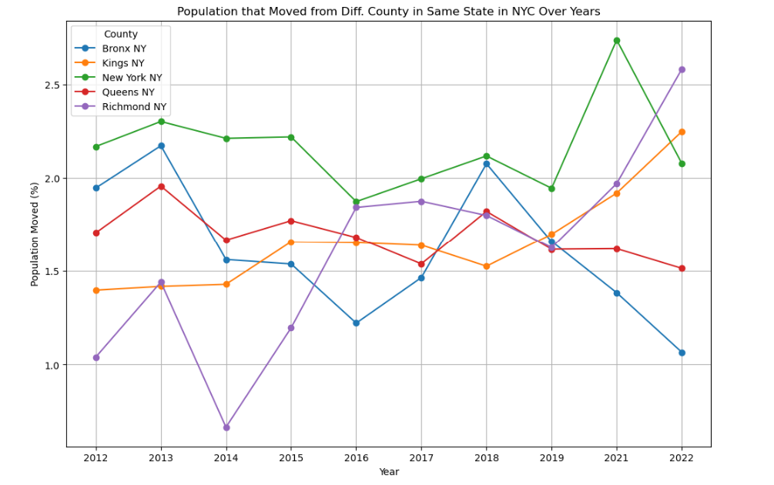

**Mobility Population in Surrounding NY State:**

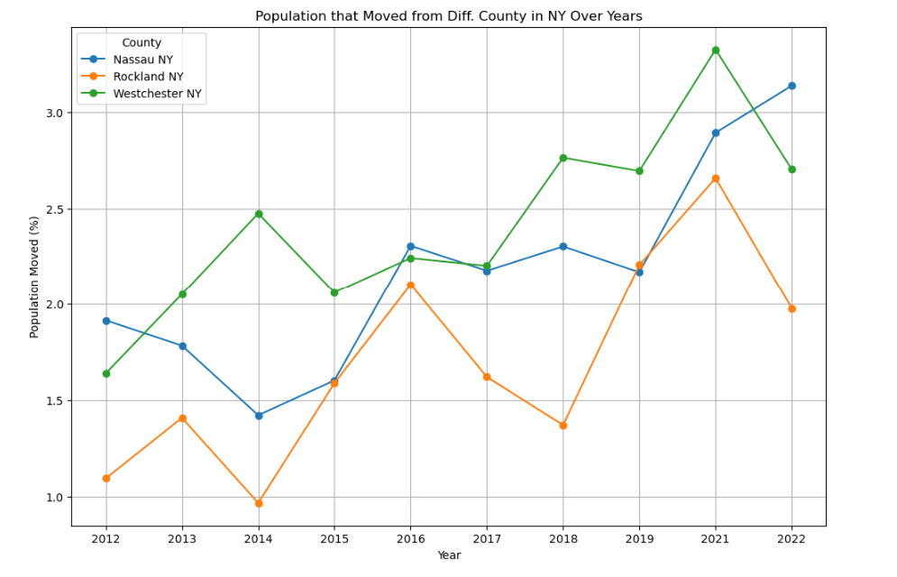

**Mobility Population in Surrounding Counties:**

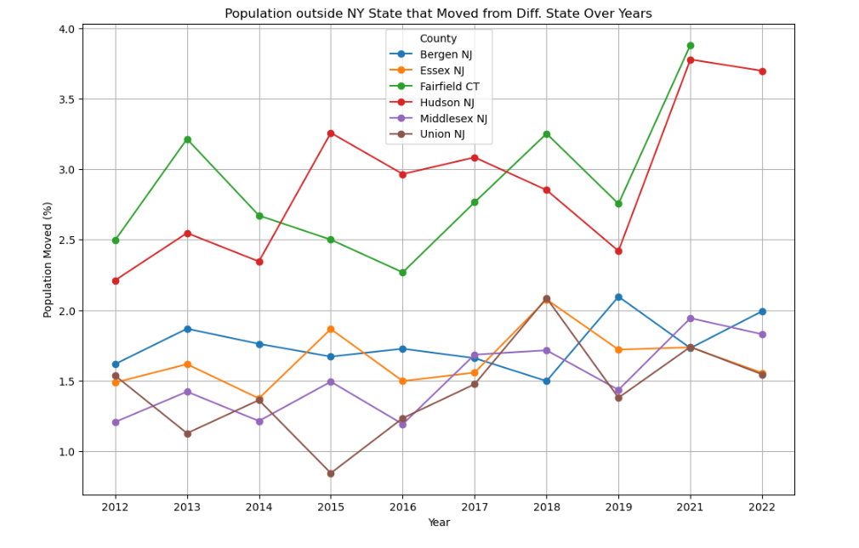

# Model Evaluation/Results with Labor:

* Calculate the percentage of Moved Population from different county to same state, NY state and NYC:
  + - NYC counties: Bronx (NY), Kings(NY), Richmond(NY), New York (NY), Queens (NY)
    - Outside of NYC Counties: Westchester (NY), Rockland (NY), Nassau (NY)
* Calculate percentage of Moved Population from different county to same state, Surrounding State:
  + - Bergen (NJ), Hudson (NJ), Essex (NJ), Middlesex (NJ), Union (NJ)
    - Fairfield (CT)
* This analysis visualized the mobility percentage within NYC and the surrounding counties. 3 out of 5 counties in NYC, there is population decline moving into NYC counties, while there is an increase in mobility in surrounding states. Looking at the moved population in NY state outside of NYC counties, the same decline also appears.

**Vacancy Rate by Year in NYC:**

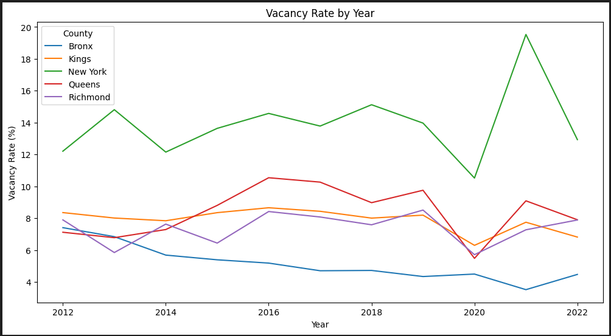

**Vacancy Rate by County in NYC - Boxplot (grouped by county):**

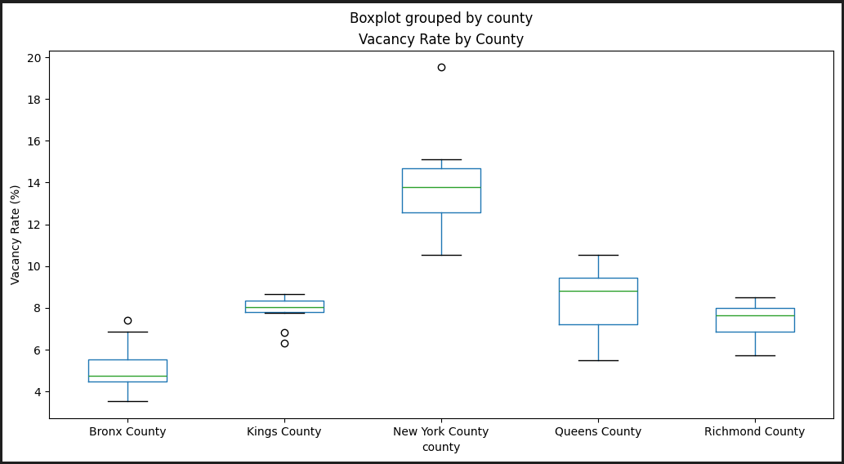

**Vacancy Rate by Period, before/after lockdown in NYC - Boxplot (grouped by period):**

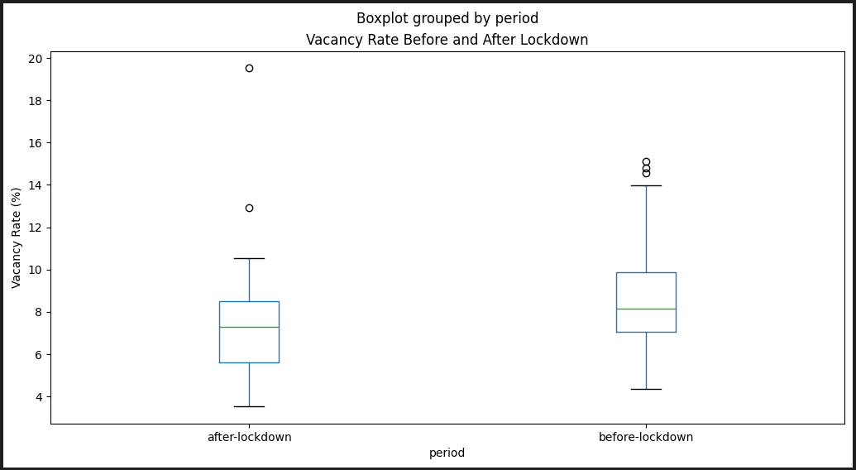

# Model Evaluation/Results with Vacancy Rate:

* Analyze Vacancy Rate in NYC Boroughs before and after lockdown 2020
* Sourced from the US Census Bureau’s American Community 1 Year Survey
  + Limitation: 2020 1y ACS data unavailable for 2020, pandemic lockdown limited ability to collect data.
  + Limitation: 2023 ACS data is not yet available.
* Compute vacancy rate (%) of number of vacant housing units by total number of housing units.
* Visualize range of data by borough (county) and before/after pandemic lockdown, as well as trends in vacancy rate as a time series between 2012 and 2022.
* The mean vacancy rate was 8.54%, and the median was 7.90%, with a standard deviation of 3.25%.
* T-Test showed a p-value of 0.50, which makes the impact of the pandemic lockdown statistically insignificant to predict vacancy rates
  + Exception: When analyzing for The Bronx, the p-value was 0.027, which is statistically significant.
  + Note limitations for 2020.

**Housing Values in NYC and Surrounding Counties Over Time:**

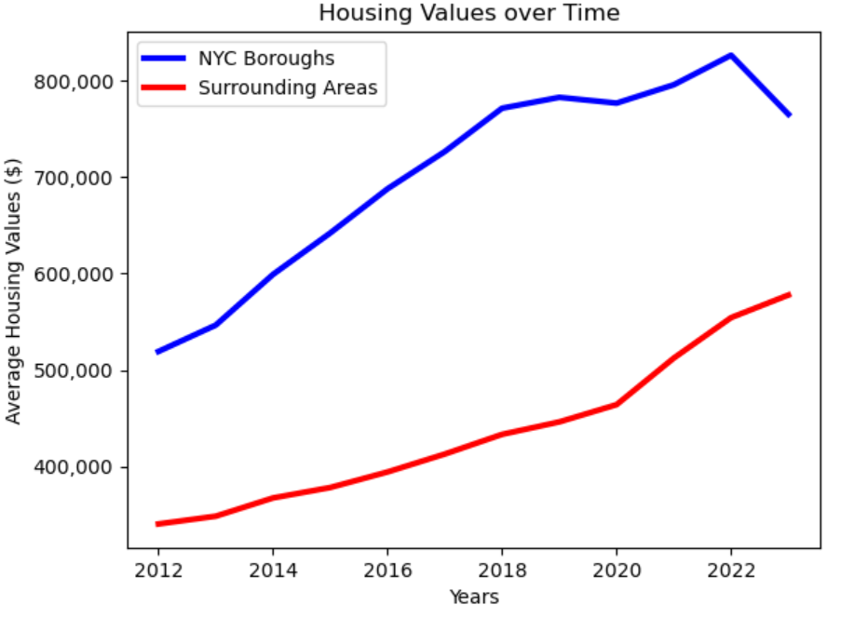

**Correlation btw Avg 30Y Fixed Mortgage Rates and Avg. Housing Values**

* **Surrounding Counties:**

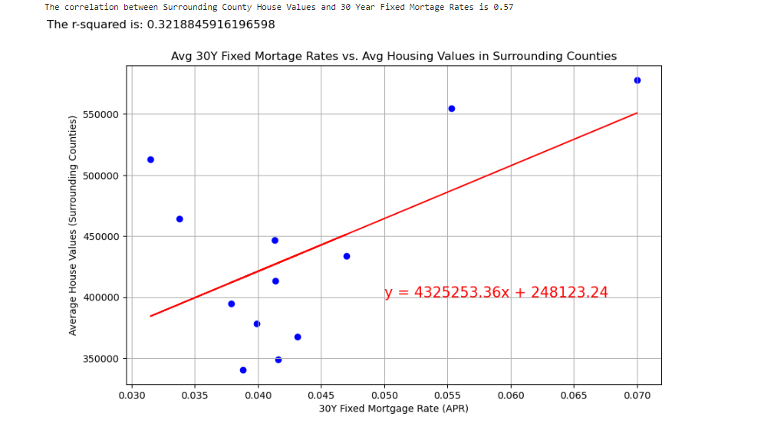

**Correlation btw Avg 30Y Fixed Mortgage Rates and Avg. Housing Values**

* **NYC Counties:**

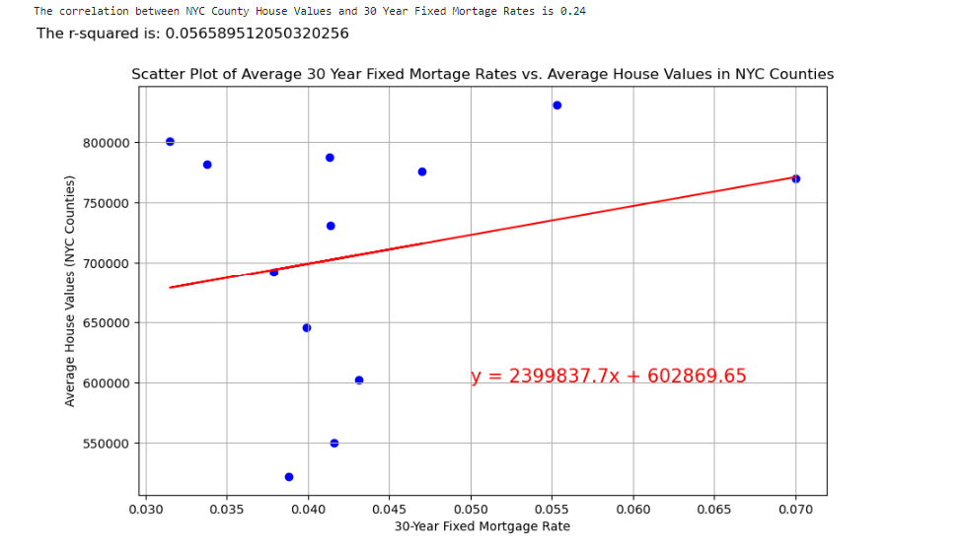

**Avg 30Y Fixed Mortgage Rates - (2012 - 2022):**

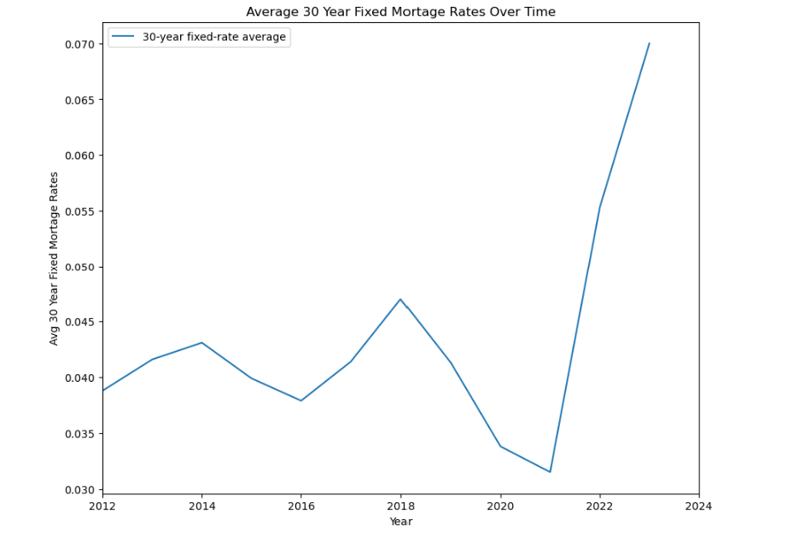

**Housing Values in Surrounding Counties - (2012 - 2022):**

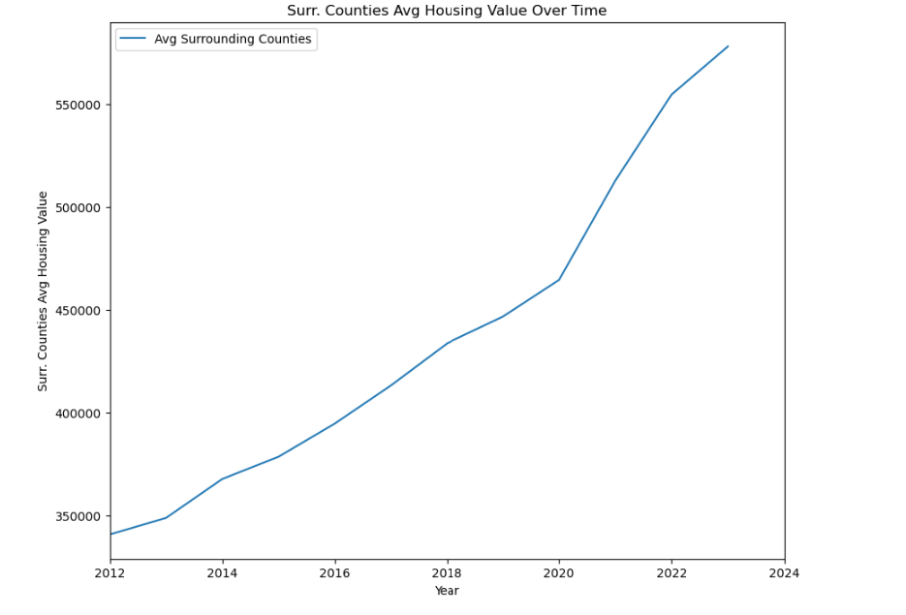

**Housing Values in NYC - (2012 - 2022):**

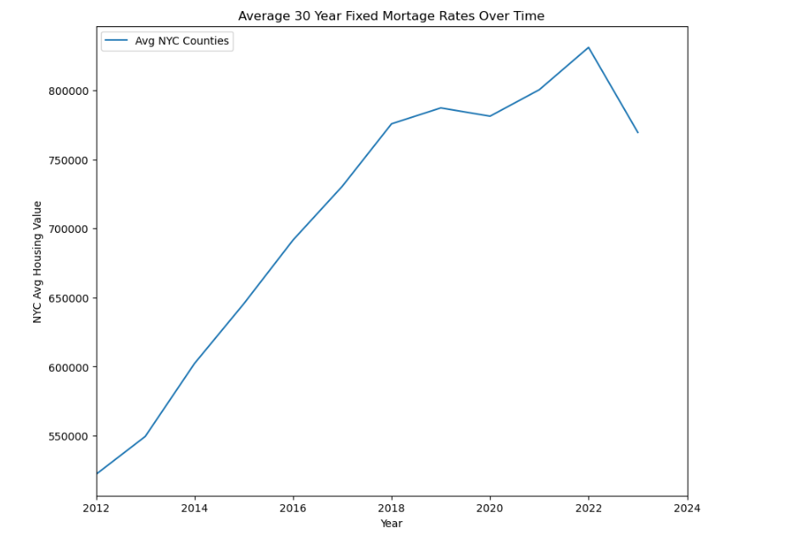

# Model Evaluation/Results with Vacancy Rate:

* There is a steep increase in values in both lines during the pandemic (2020-2021)
* Surrounding values went up and NYC when down post pandemic, particularly when the Federal Reserve started implementing interest rates increases to stave off inflation.
* The expectation is to see a negative correlation between Housing Values vs Int Rate. Post pandemic, there is no correlation between two housing values and interest rate. Even though the housing values went down in NYC post pandemic, they still stayed in the considerably higher end.

**Results**

# Key Findings

* For vacancy rates, the t-test for before and after lockdown had a p-value of 0.50, which implies that lockdown had no statistically significant impact on vacancy rates. The exception is The Bronx, which had a p-value of 0.2.
* Limitations regarding vacancy rates: Census data for 2020 was unavailable in the ACS 1y summary, which we used as the source, because lockdown impacted data collection.
* There is a strong correlation between the average weekly wage and the year. The correlation is 0.88 out of 1.00. There is a 0.9 out of 1.00 correlation, between total quarter wages and months 1,2,3 for employment.
* The highest wages increased was about 2%. There has the most value-counted job data for the year 2021.
* Significant increase in Interest Rate after covid 2019 while House Values are increased surrounding counties and decreased in NYC counties
* After 2020, housing Values increase in surrounding counties while decline in NYC.
* Looking at the correlation between Interest Rate and Housing Values, there is no correlation, however r - square is low in both NYC and Surrounding Counties data set, meaning that independent variable is not effectively explaining the variation in the dependent variable.